GUVI: Zen Class — Part 1:**Find the culprits and nail them — debugging javascript:**

**Corrected code:fix.html**

**<!DOCTYPE html>**

**<html>**

**<body>**

**<script>**

**alert("I’m JavaScript!");**

**</script>**

**Whats the error in this ?**

**the error is this statement inside alert is not properly qouted.**

**</body>**

**</html>**

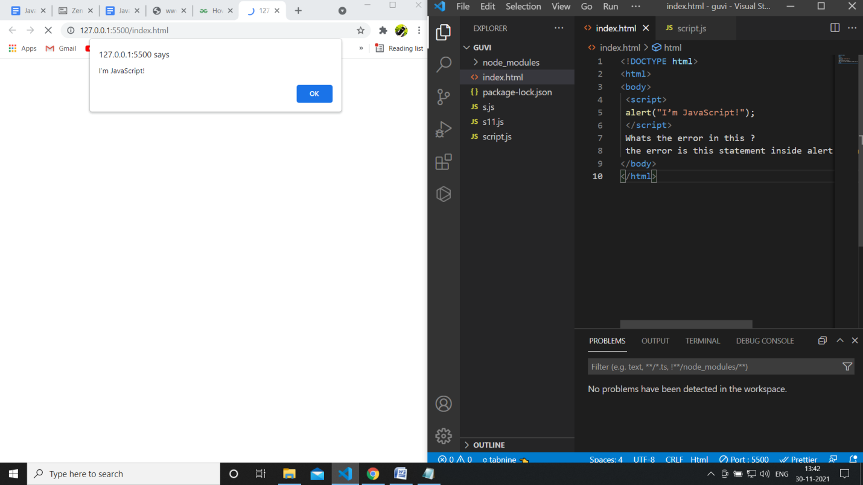

**----------------------------------------------------------------------------------------------------**

**Fix.html**

**<!DOCTYPE html>**

**<html>**

**<body>**

**<script src="script.js"></script>**

**</body>**

**</html>**

**<!-- error in this code is inproper linking of js file -->**

**Script.js:**

**alert("I’m invoked!");**

**o/p:** 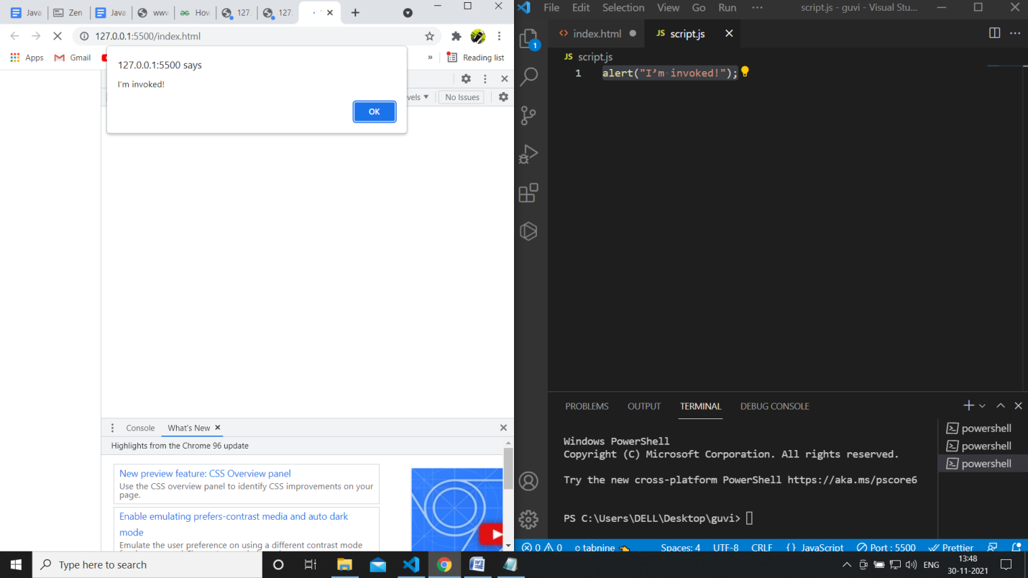

**----------------------------------------------------------------------------------------------------**

explain.html

<!DOCTYPE html>  
<html>  
<body>  
 <script src=”script.js”></script>  
</body>  
</html>

script.js

alert("I'm JavaScript!");  
alert('Hello') // this line is not having semicolon  
alert(`Wor  
 ld`)  
alert(3 +  
1  
+ 2); // this is multiple line code and its working

**Explanation:**

**The above snippets first display**

**I’m JavaScript! Then after clicking on ok it gives hello and then wor id and then lastly 6.**

**Fix the below to alert**Guvi geek

fix.html

<!DOCTYPE html>  
<html>  
<body>  
 <script src=”script.js”></script>  
</body>  
</html>

script.js

let admin=9, fname=10.5;   
fname = "Guvi";  
lname = "geek"  
admin = fname+lname;alert( admin ); // "Guvi geek"

**code:**

let admin=9, fname=10.5;

fname = "Guvi";

lname = "geek"

admin = fname+" "+lname;

alert( admin ); // "Guvi geek"

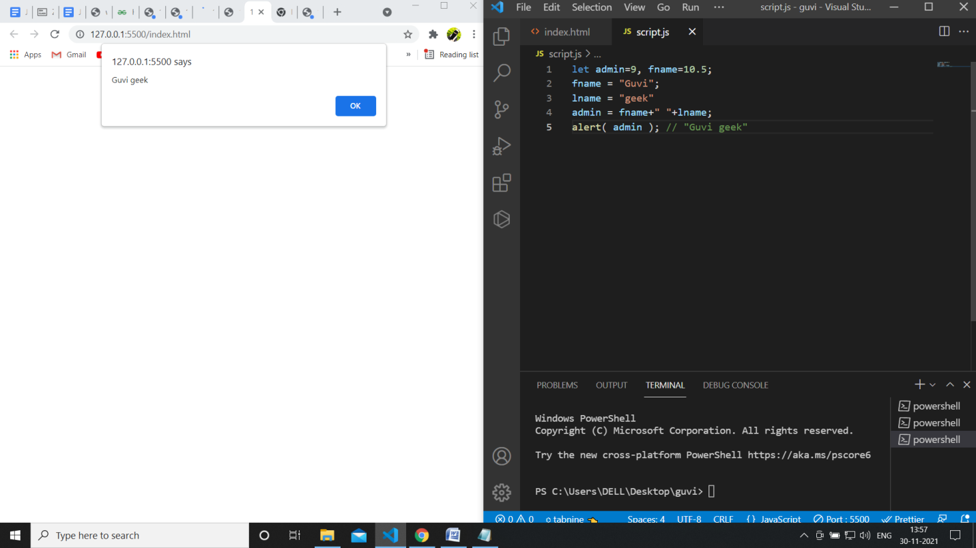

**Fix the below to alert**hello Guvi geek

fix.html

<!DOCTYPE html>  
<html>  
<body>  
 <script src=”script.js”></script>  
</body>  
</html>

script.js

let fname=10.5;   
fname = "Guvi";  
lname = "geek"let name = fname+lname;alert( 'hello ${name}' );

**code:**

let fname=10.5;

fname = "Guvi";

lname = "geek"

let name = fname+" "+lname;

alert( `hello ${name}` );

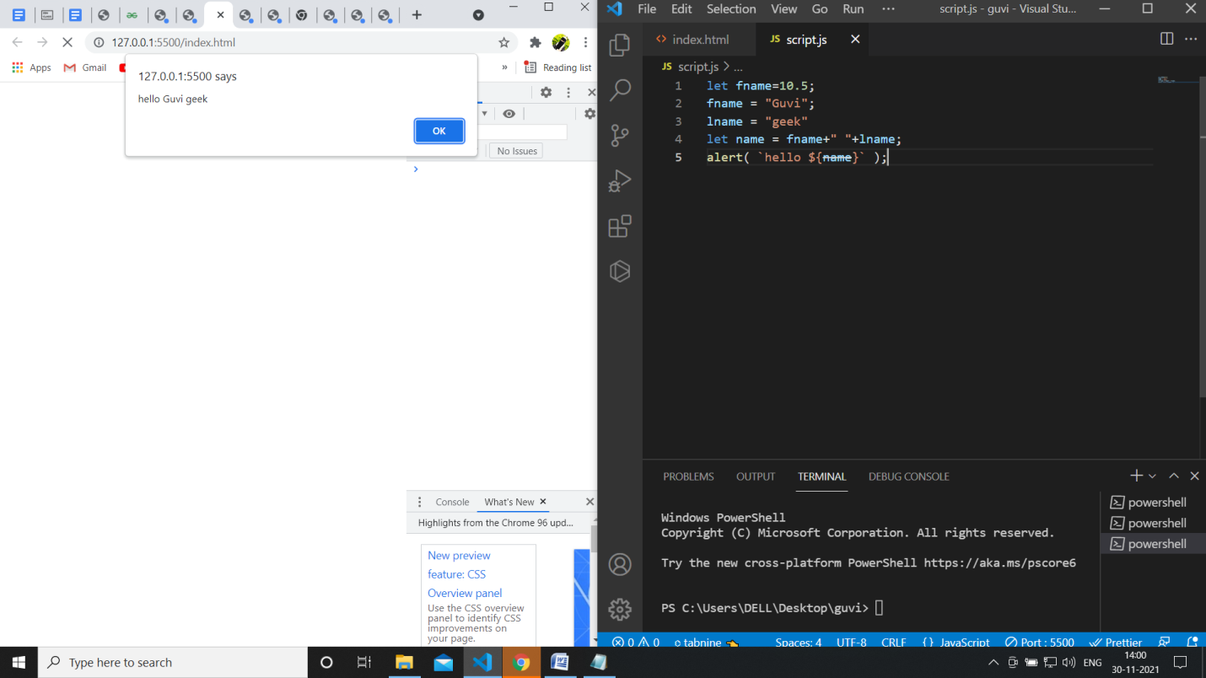

**Fix the below to alert sum of two numbers**

fix.html

<!DOCTYPE html>  
<html>  
<body>  
 <script src=”script.js”></script>  
</body>  
</html>

script.js

let a = prompt("First number?");  
let b = prompt("Second number?");  
alert(a + b);

let a = parseInt(prompt("First number?"));

let b = parseInt(prompt("Second number?"));

alert(a + b);

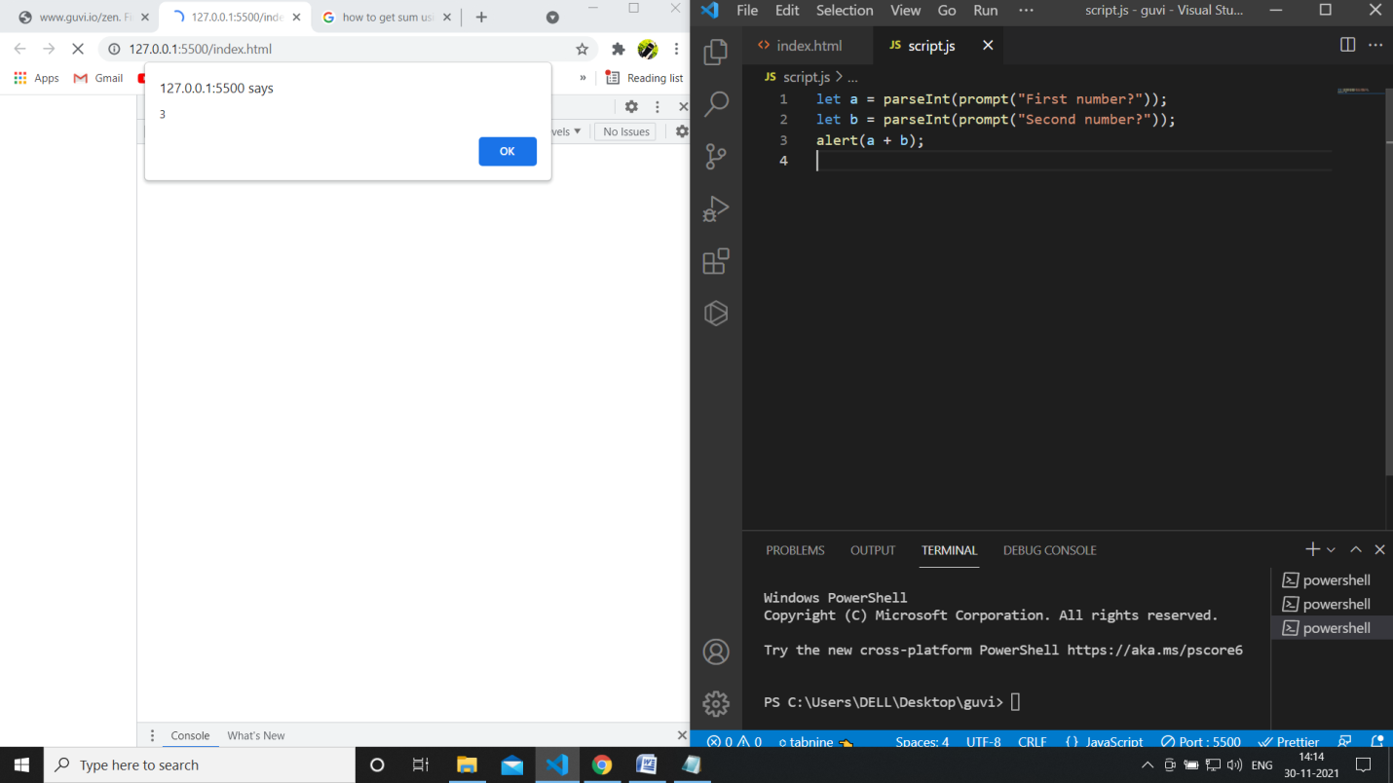

**If you run the below scritpt you will get “**Code is Blasted**”**

**Explain Why the Code is blasted and how to diffuse it and get “**Diffused**”.**

fix.html

<!DOCTYPE html>  
<html>  
<body>  
 <script src=”script.js”></script>  
</body>  
</html>

script.js

var a = "2" > "12";//Don't touch below this  
if (a) {  
 console.log("Code is Blasted")  
}  
else  
{  
 console.log("Diffused")   
}

**we are getting code is blasted because it satisfying the condition (if)**

**we make change in a that is to “2”<”12” then we get diffused.**

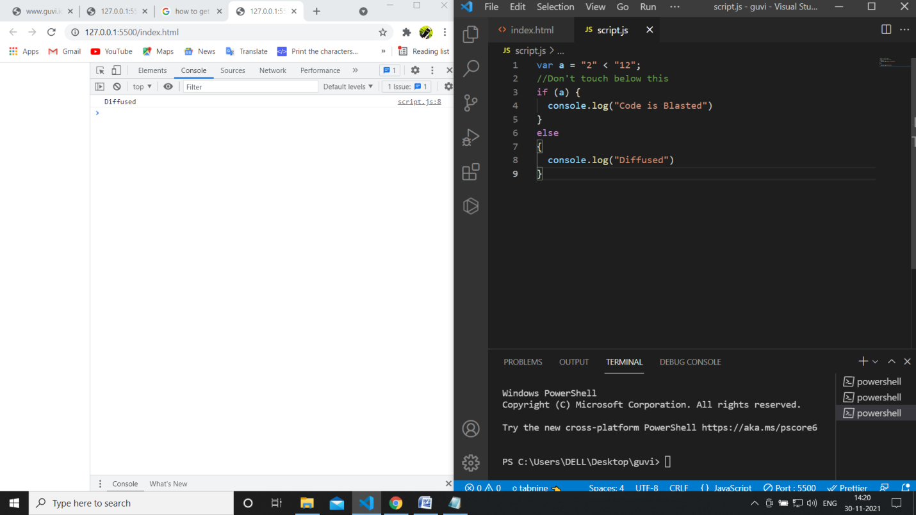

**How to get the success in console.**

**If we make a variable as integer then ig we enter string as input it cannot parse then it execute the else statement that is Success.**

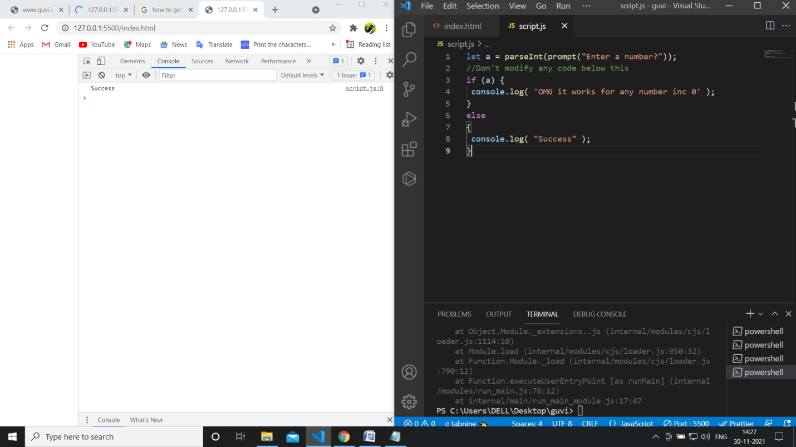

**How to get the correct score in console.**

let value = parseInt(prompt('How many runs you scored in this ball'));

if (value === 4) {

      console.log("You hit a Four");

} else if (value === 6) {

      console.log("You hit a Six");

} else {

      console.log("I couldn't figure out");

}

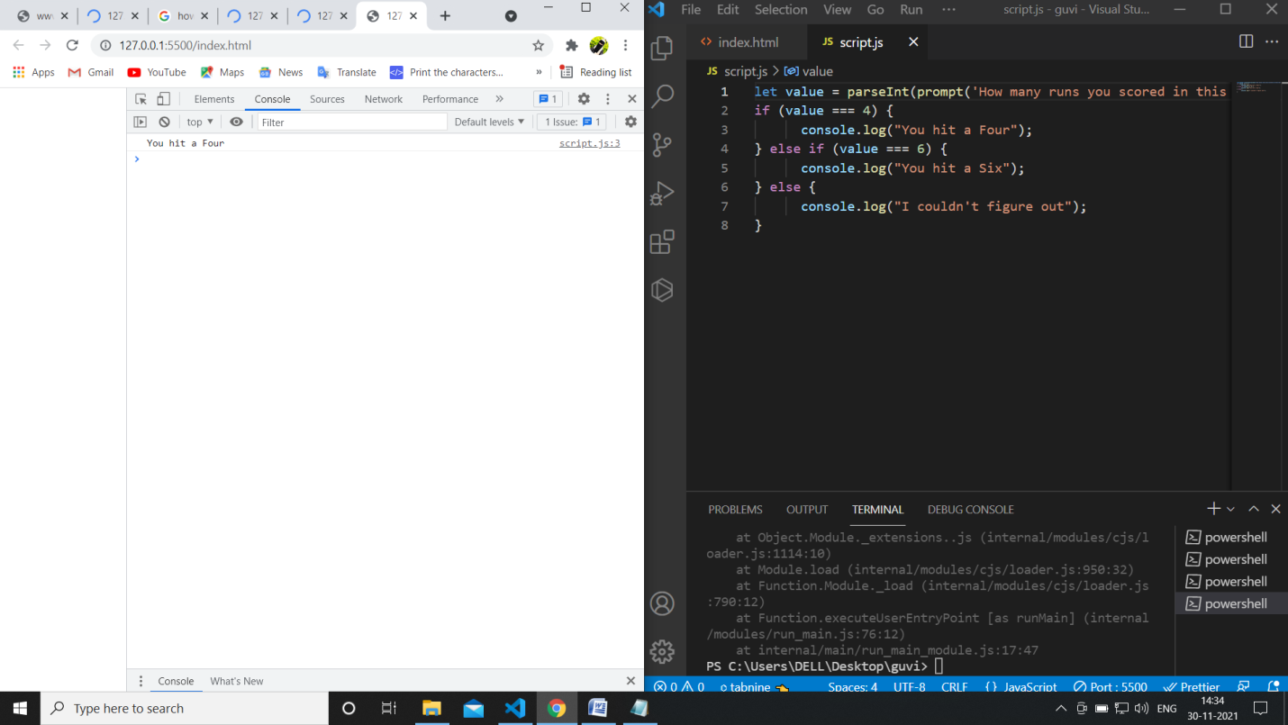

**Fix the code to welcome the Employee**

let login = 'Employee';

let message = (login == 'Employee') ? 'welcome':

  (login == 'Director') ? 'Greetings' :

  (login == '') ? 'No login':

  '';

  console.log(message);

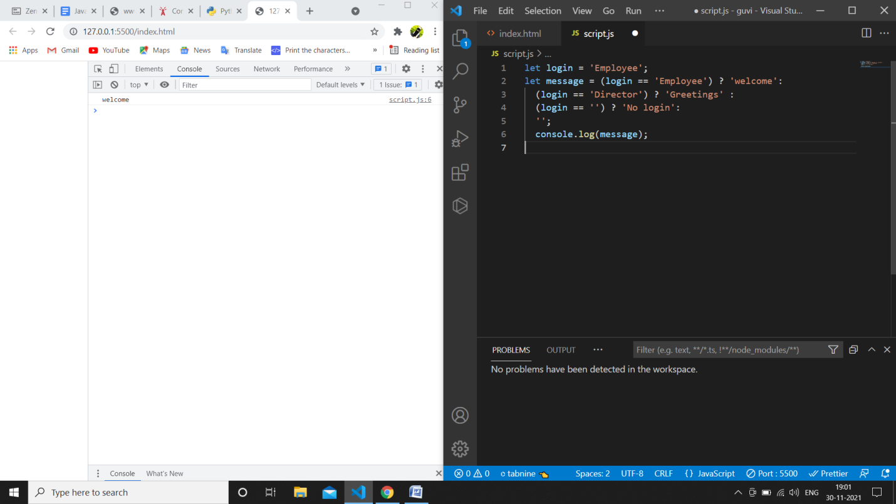

**Fix the code to welcome the boss**

// You cant change the value of the msg

let message;

if (null || 2 || undefined )

{

  message = "welcome boss";

}

else

{

  message = "Go away";

}

  console.log(message);

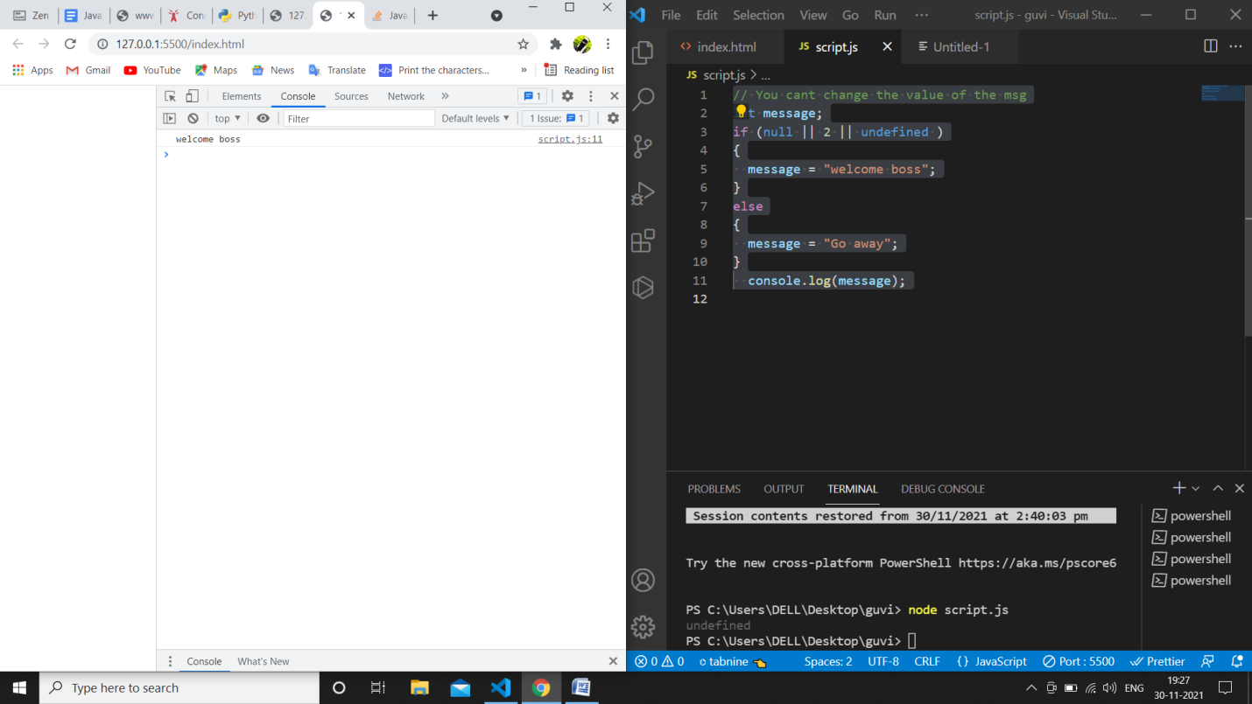

**Fix the code to welcome the boss**

let message;

let lock = 2;

//Dont change any code below this

if (!(null || lock || undefined ))

{

  message = "Go away";

}

else

{

 message = "welcome";

}

  console.log(message);

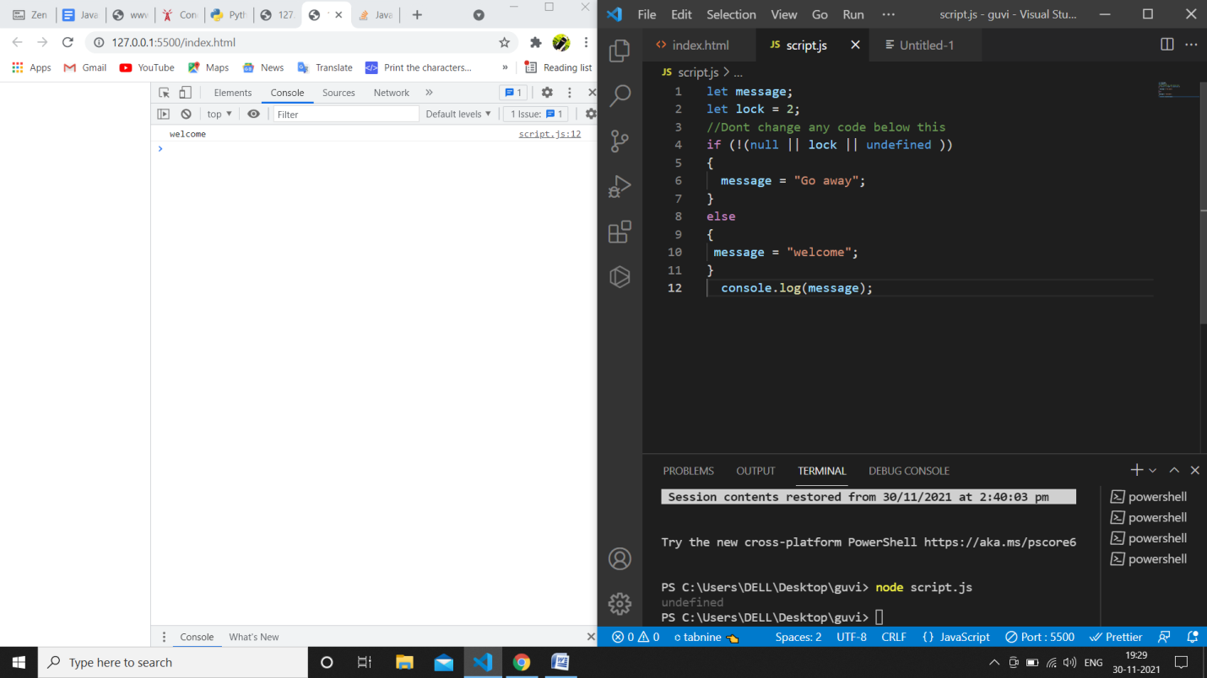

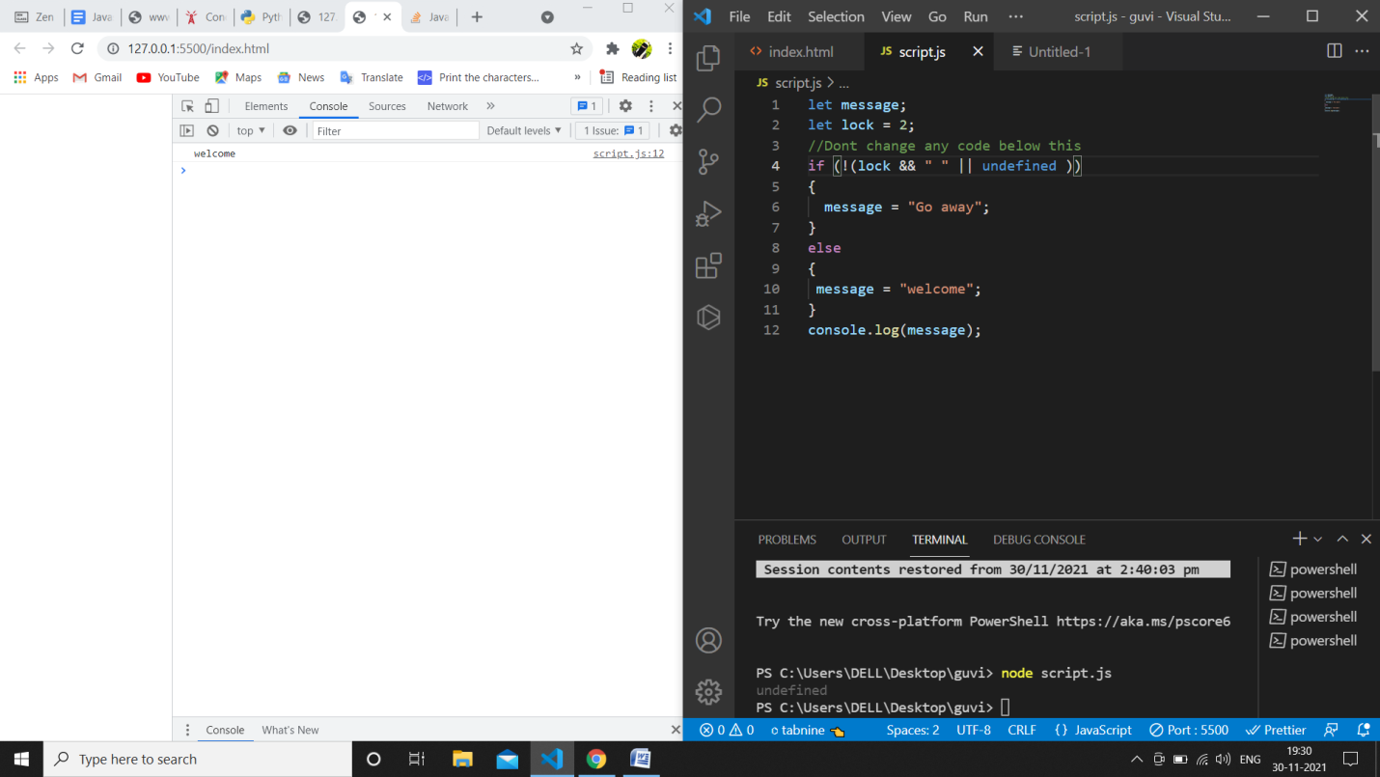

**Change the code to print**

3

2

1

//You can change only 2 characters

let i = 3;

while (i) {

  console.log( i--);

}

**Change the code to print even numbers**

//You are allowed to modify only one character

for (let num = 2; num <= 20; num += 2) {

  console.log(num);

}

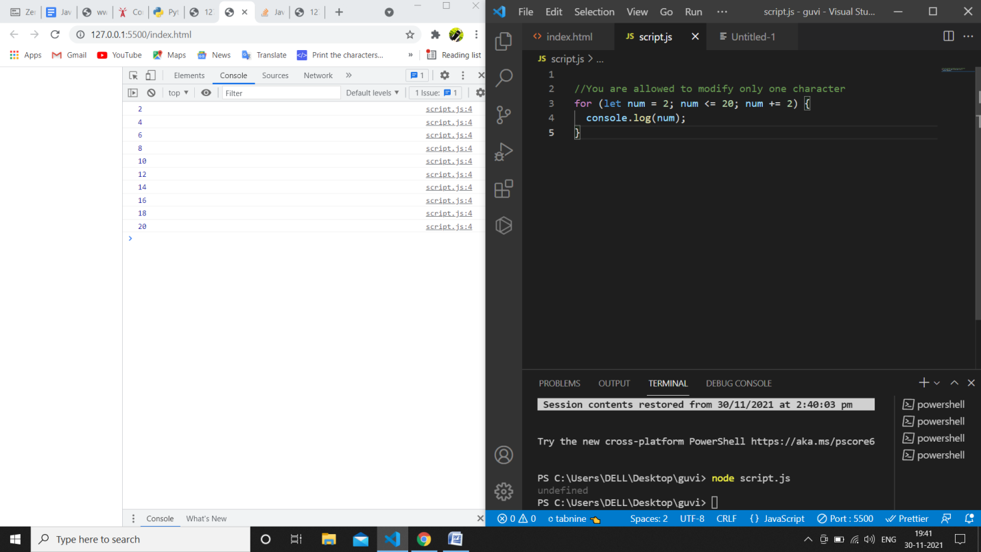

**Change the code to print all the gifts**

let gifts = ["teddy bear", "drone", "doll"];

for (let i = 0; i < 3; i++) {

  //console.log(gifts[i])

  console.log(`Wrapped ${gifts[i]} and added a bow!`);

}

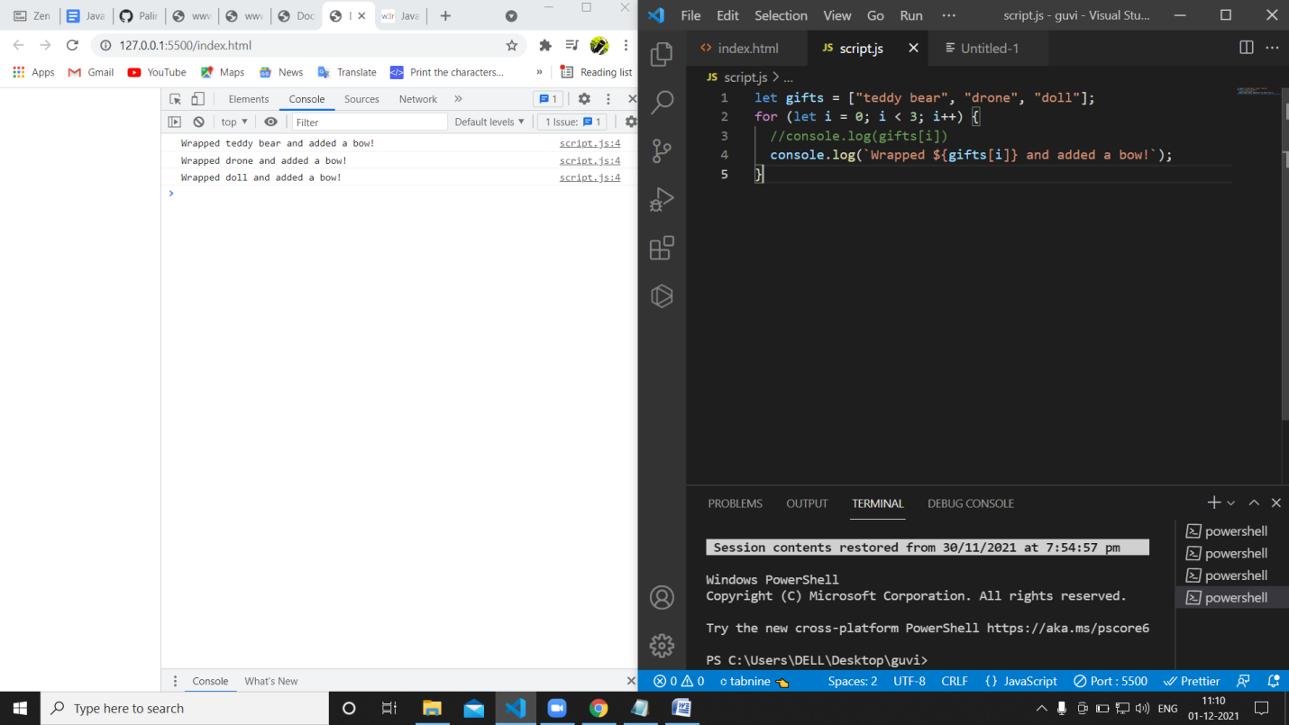

**Fix the code to disarm the bomb.**

let countdown = 100;

while (countdown > 0) {

  countdown--;

  if(countdown == 0)

  {

   console.log("disarm the bomb");

  }

}

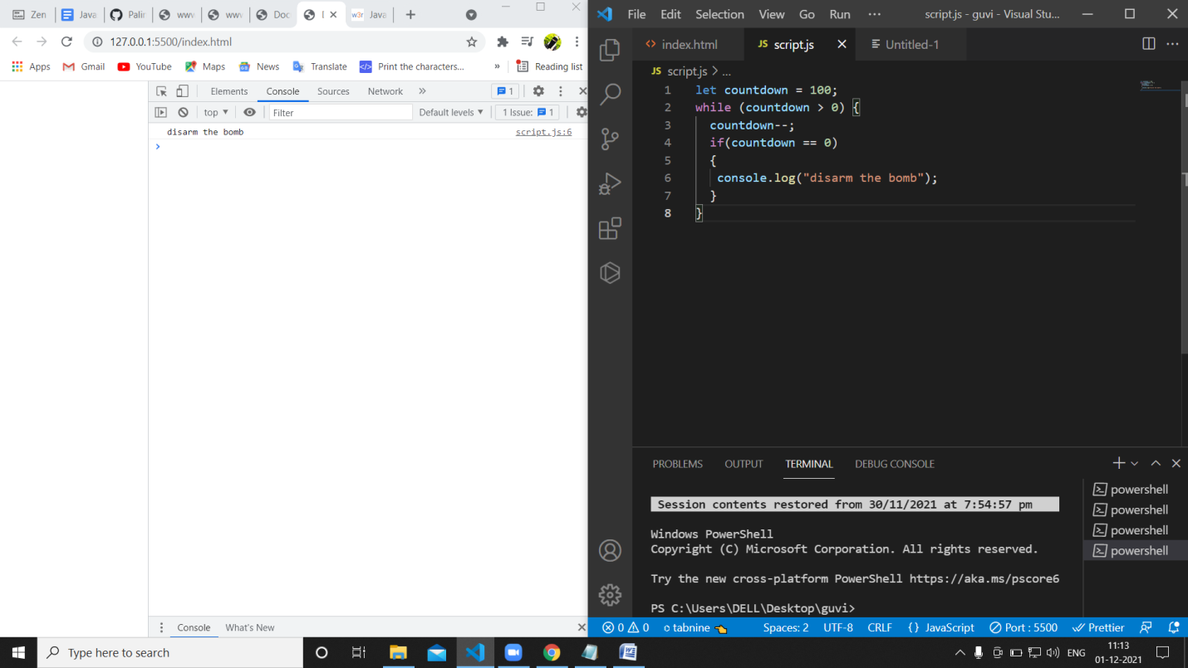

Whats the msg printed and why?

The first if condition is satisfying then it print first if condition output hi.

# ---------------------------------------------------------------------------------------------------------------------GUVI: Zen Class — Part 2 : Find the culprits and nail them — debugging javascript loops

Write a code to print the numbers in the array

**Output**: 1234567891011

var numsArr = [ 1, 2, 3, 4, 5, 6, 7, 8, 9, 10, 11];

var new_string = [];

for (var i = 0; i < 11; i++) {

 new_string += numsArr[i]

}

console.log(new_string);

**o/p: 1234567891011**

Write a code to print from last to first with spaces (Make sure there is no space after the last element 1)

**Output**: 11 10 9 8 7 6 5 4 3 2 1

var numsArr=[0,1,2,3,4,5,6,7,8,9,10,11]

var new_string = "";

for (var i = 11; i >0; i--) {

 new_string +=numsArr[i] + " "

}

console.log(new_string.trim(" "));

**o/p: 11 10 9 8 7 6 5 4 3 2 1**

**//last element without ,**

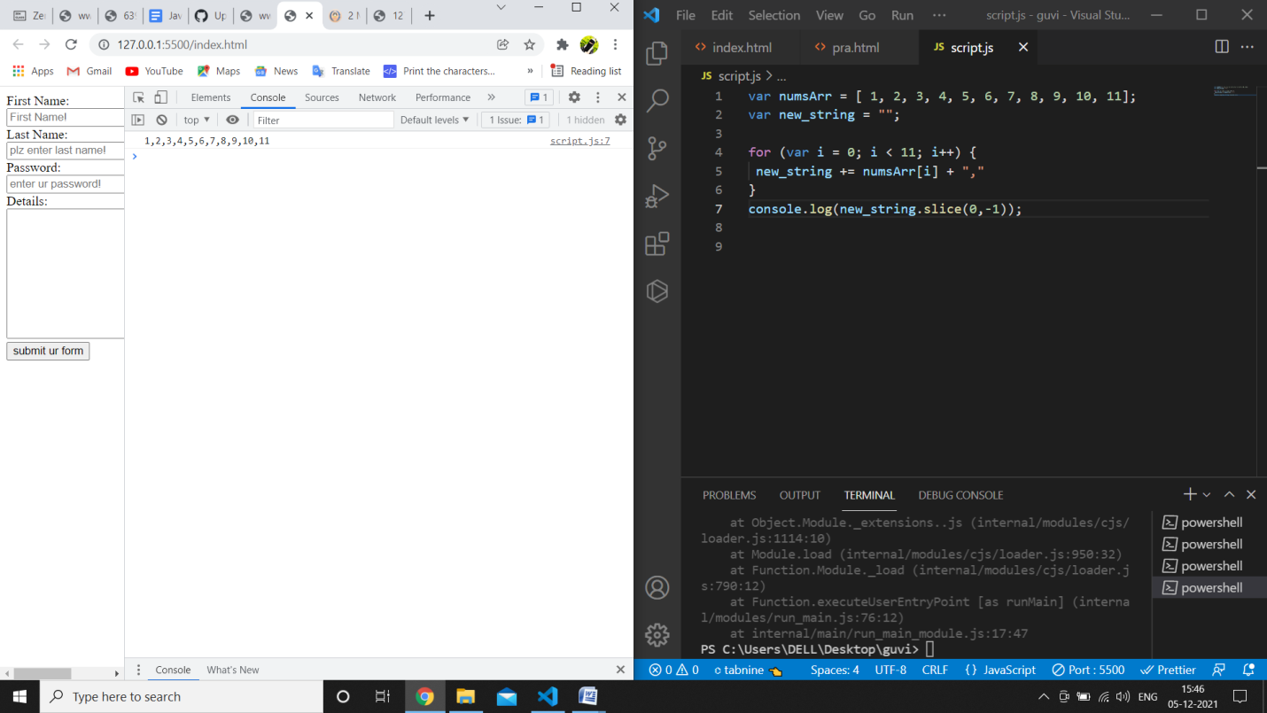

**//sum of array elements**

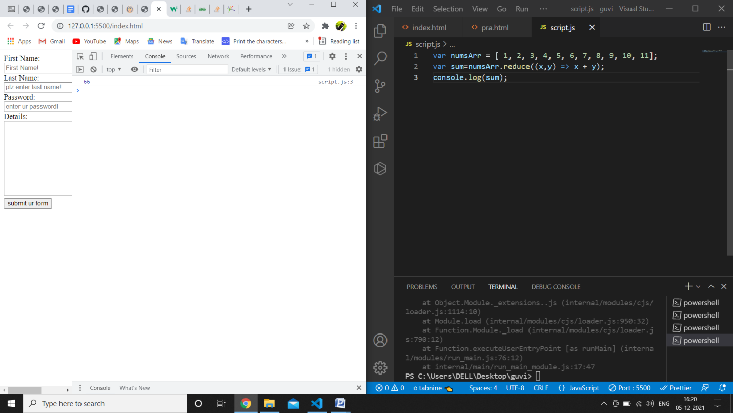

Write a code to add the even numbers only  
**Output**: 30

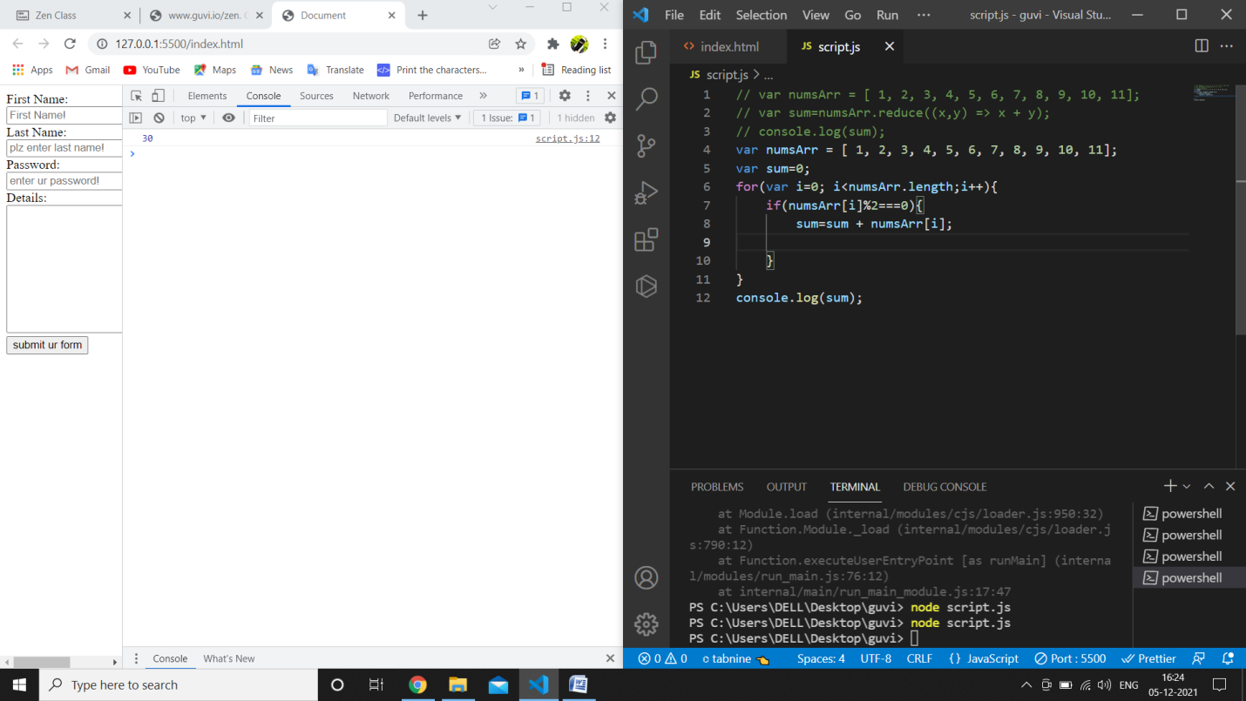

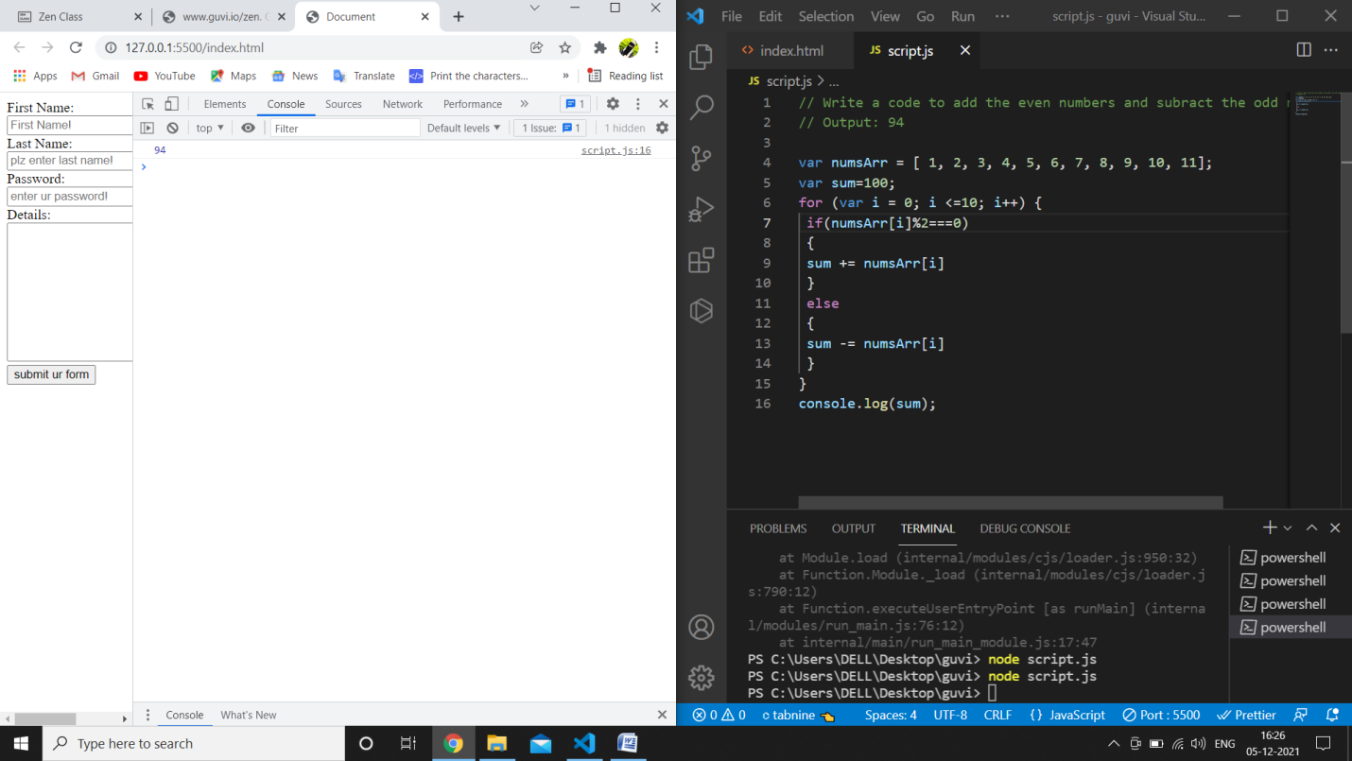

Write a code to print inner arrays  
**Output**:Array(5) [ 1, 2, 3, 4, 5 ]  
Array(6) [ 6, 7, 8, 9, 10, 11 ]

var numsArr = [[1, 2, 3, 4, 5],[ 6, 7, 8, 9, 10, 11]];

for (var i = 0; i < numsArr.length; i++) {

 console.log( numsArr[i])

}

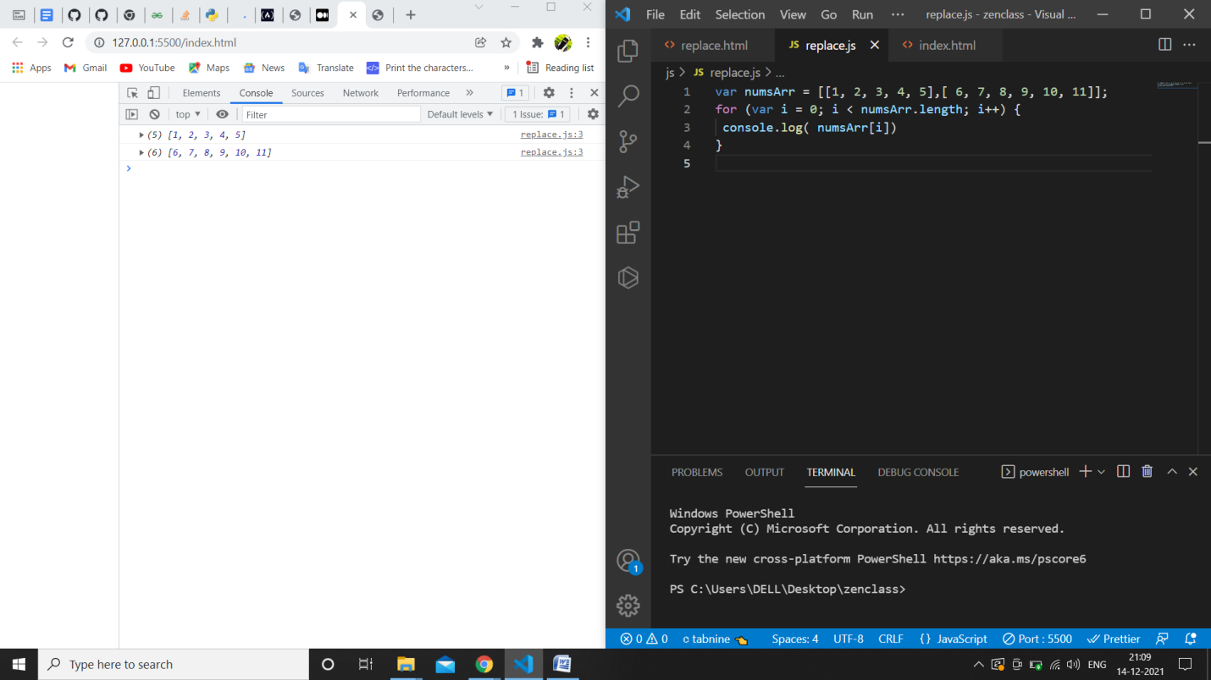

Write a code to print elements in the inner arrays  
**Output**: 1234567891011

var numsArr = [[1, 2, 3, 4, 5],[ 6, 7, 8, 9, 10, 11]];

var str_all="";

for (var i = 0; i < numsArr.length; i++) {

//  var inner_array = numsArr[i];

 for(var j = 0 ; j < numsArr[i].length;j++ ){

     str_all+=numsArr[i][j]+""

 }

}

console.log(str_all);

Write a code to replace the array value — If the index is even, replace it with ‘even’.**Output**: [ [“even”, 2, “even”, 4, “even”], [6, “even”, 8, “even”, 10, …] ]

var numsArr = [[1, 2, 3, 4, 5],[ 6, 7, 8, 9, 10, 11]];

var str_all=[];

for (var i = 0; i < numsArr.length; i++) {

 var inner_array = numsArr[i];

 for(var j = 0 ; j < inner_array.length;j++ ){

      if(j %2 == 0 )

      {

         str_all.push("even");

       }

       else{

           str_all.push(inner_array[j]);

       }

    }

    }

    console.log(str_all);

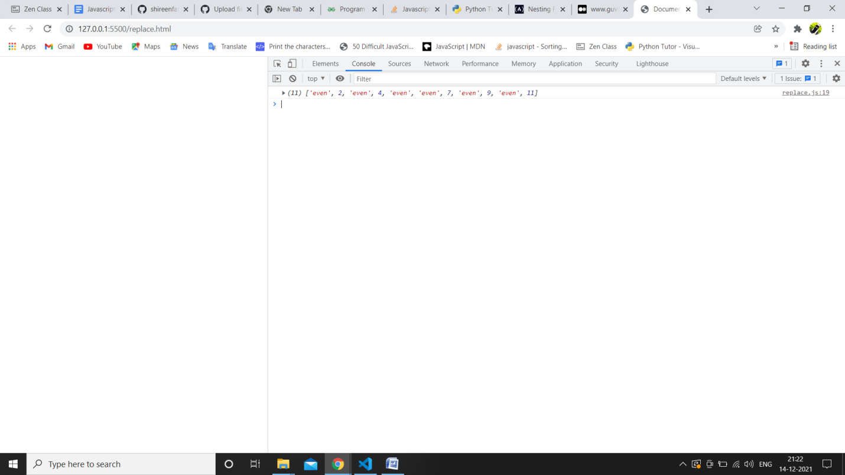

<https://medium.com/@reach2arunprakash/guvi-zen-simple-debugging-tasks-adcdc2d3249d>

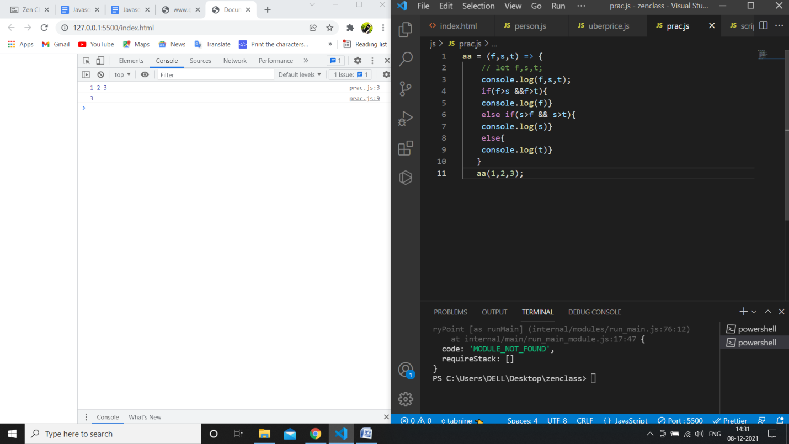

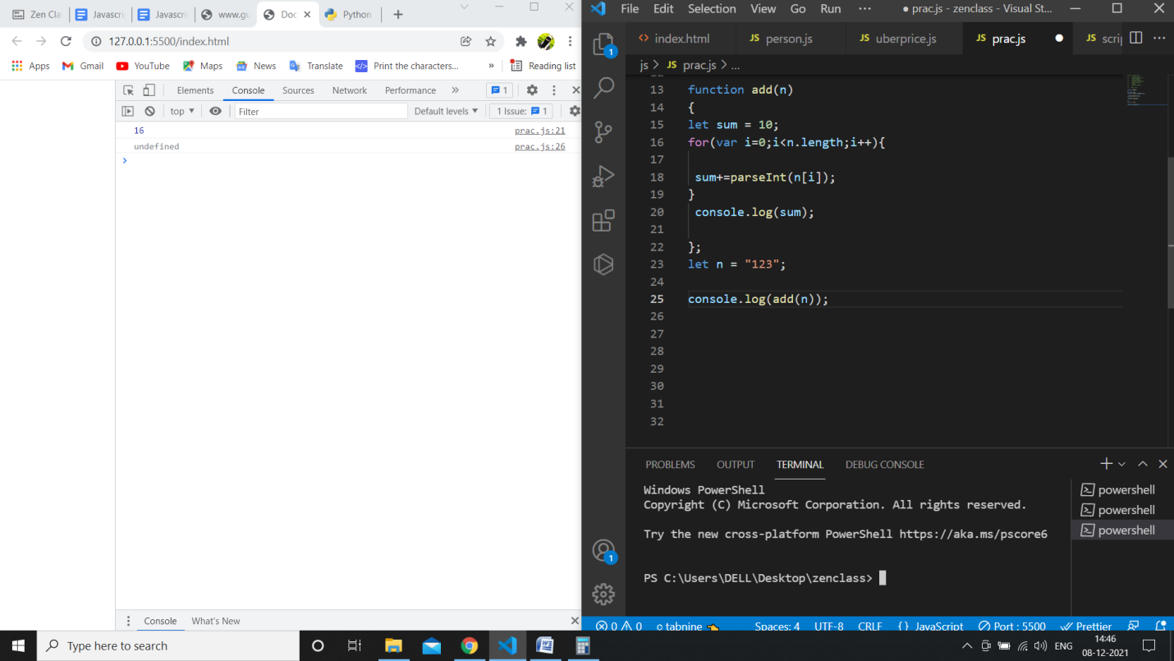

Write a code to print elements in the inner arrays in reverse  
**Output**: 11 10 9 8 7 6 5 4 3 2 1

var numsArr = [[1, 2, 3, 4, 5],[ 6, 7, 8, 9, 10, 11]];

var arr=numsArr.reverse();

var str_all=0;

for (var i = 0; i < numsArr.length; i++) {

 var inner_array = numsArr[i];

 for(var j = inner_array.length-1; j >=0 ;j-- ){

     str_all+=inner_array[j];

     console.log(inner_array[j]);

 }

}

Write a code to add elements in the inner arrays based on odd or even values  
**Output**:  
36  
30

var numsArr = [[1, 2, 3, 4, 5],[ 6, 7, 8, 9, 10, 11]];

var sum_odd=0;

var sum_even=0;

for (var i = 0; i < numsArr.length; i++) {

 var inner_array = numsArr[i];

 for(var j = 0 ; j < inner_array.length;j++ ){

 if(numsArr[i][j]%2===0)

 {

 sum_odd += inner_array[j];

 }

 else

 {

 sum_even += numsArr[i][j];

 }

}

}

console.log(sum_odd);

console.log(sum_even);

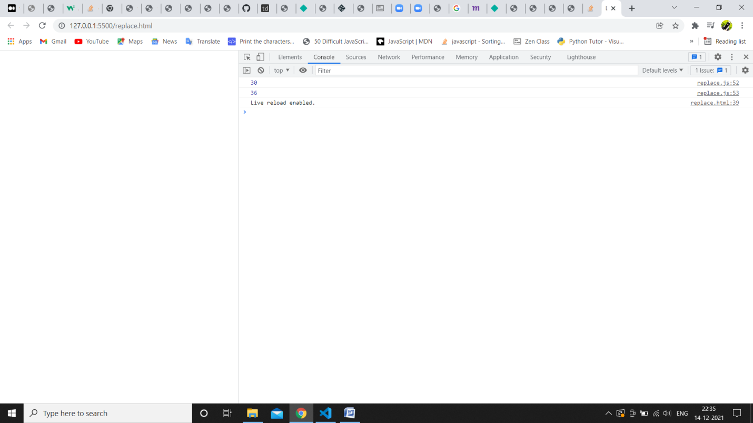

Write a code to replace the array value — If the number is even, replace it with ‘even’.

**Output**:[ 1, “even”, 3, “even”, 5, “even”, 7, “even”, 9, “even”, … ]

var numsArr = [ 1, 2, 3, 4, 5, 6, 7, 8, 9, 10, 11];

var newArr =[];

for (var i = 0; i <=10; i++) {

 if(numsArr[i] %2 == 0 )

 {

    newArr.push("even")

 }else{

     newArr.push(numsArr[i]);

 }

}

console.log(newArr);

// // Write a code to replace the array value — If the index is even, replace it with ‘even’.

// // Output: [ “even”, 2, “even”, 4, “even”, 6, “even”, 8, “even”, 10, … ]

var numsArr = [ 1, 2, 3, 4, 5, 6, 7, 8, 9, 10, 11];

var newArr =[];

for (var i = 0; i <=10; i++) {

 if(i %2 == 0 )

 {

    newArr.push("even")

 }else{

     newArr.push(numsArr[i]);

 }

}

console.log(newArr);

Write a code to replace the array value — If the index is even, replace it with ‘even’.**Output**: [ “even”, 2, “even”, 4, “even”, 6, “even”, 8, “even”, 10, … ]

var numsArr = [[1, 2, 3, 4, 5],[ 6, 7, 8, 9, 10, 11]];

var str_all=0;

// var temp=[];

for (var i = 0; i < numsArr.length; i++) {

 var inner_array = numsArr[i];

 for(var j = 0 ; j < inner_array.length;j++ ){

      if(i %2 == 0 )

      {

         inner_array.push("even");

       }

       else{

           inner_array.push(inner_array);

       }

}}

console.log(inner_array);

**Fix the code to Sum of all numbers using IIFE function**

Code:

const arr = [9,8,5,6,4,3,2,1];

(function() {

 let sum = 0;

 for (var i = 0; i <arr.length; i++){

 sum += arr[i];

 }

 console.log(sum);

})(arr);

**Fix the code to gen Title caps.**

Code:

var arr = ["guvi", "geek", "zen", "fullstack"];

var ano = function (arro) {

 for (var i = 0; i < arro.length; i++) {

 console.log(arro[i][0].toUpperCase() + arro[i].substr(1));

 }

}

ano(arr);

prime:

const newArray = [1, 3, 2, 5, 10];

const isPrime = num => {

  for (let i = 2; i < num; i++) {

    if (num % i === 0) return false;

  }

  return num !== 1;

};

const myPrimeArray = newArray.filter(isPrime);

console.log(myPrimeArray);

sum:

const num = [10, 20, 30, 40,50,60,70,80,90,100];

let sum = (a, b) =>a+b;

sum = num.reduce(sum)

console.log(sum);

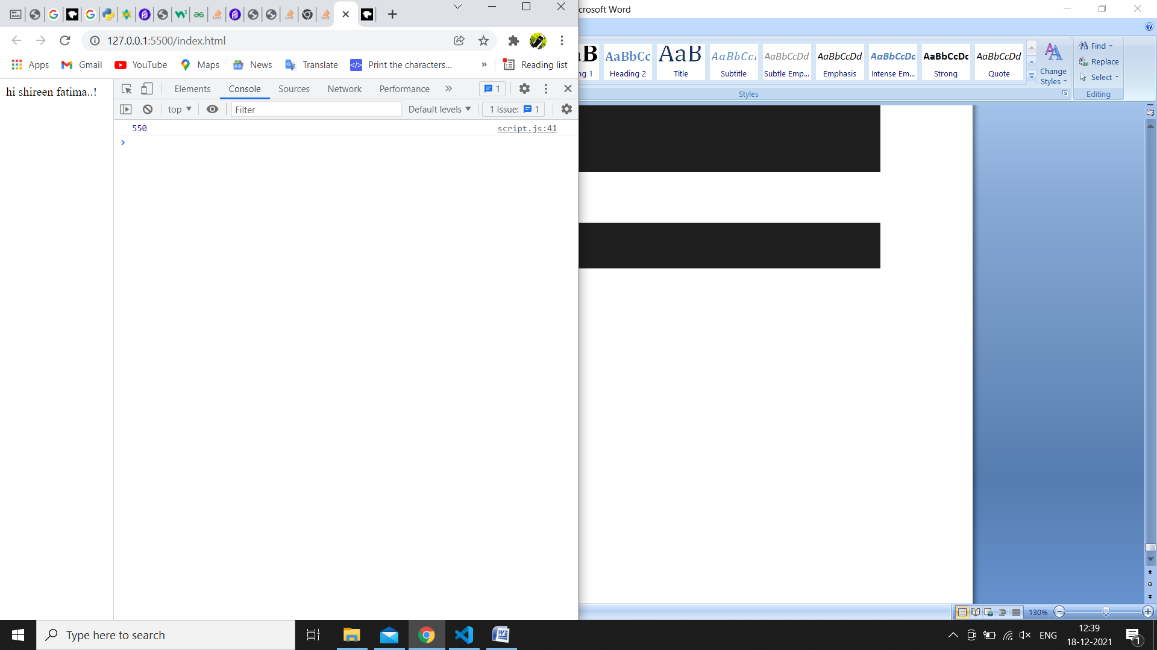

Odd numbers:

var arr = [1, 2, 3, 5, 7, 79, 7, 2, 6, 9, 4];

(function() {

 for (var i = 0; i < arr.length; i++) {

 if (arr[i] % 2 !== 0) {

 console.log(arr[i]);

 }}

})();

Reverse:

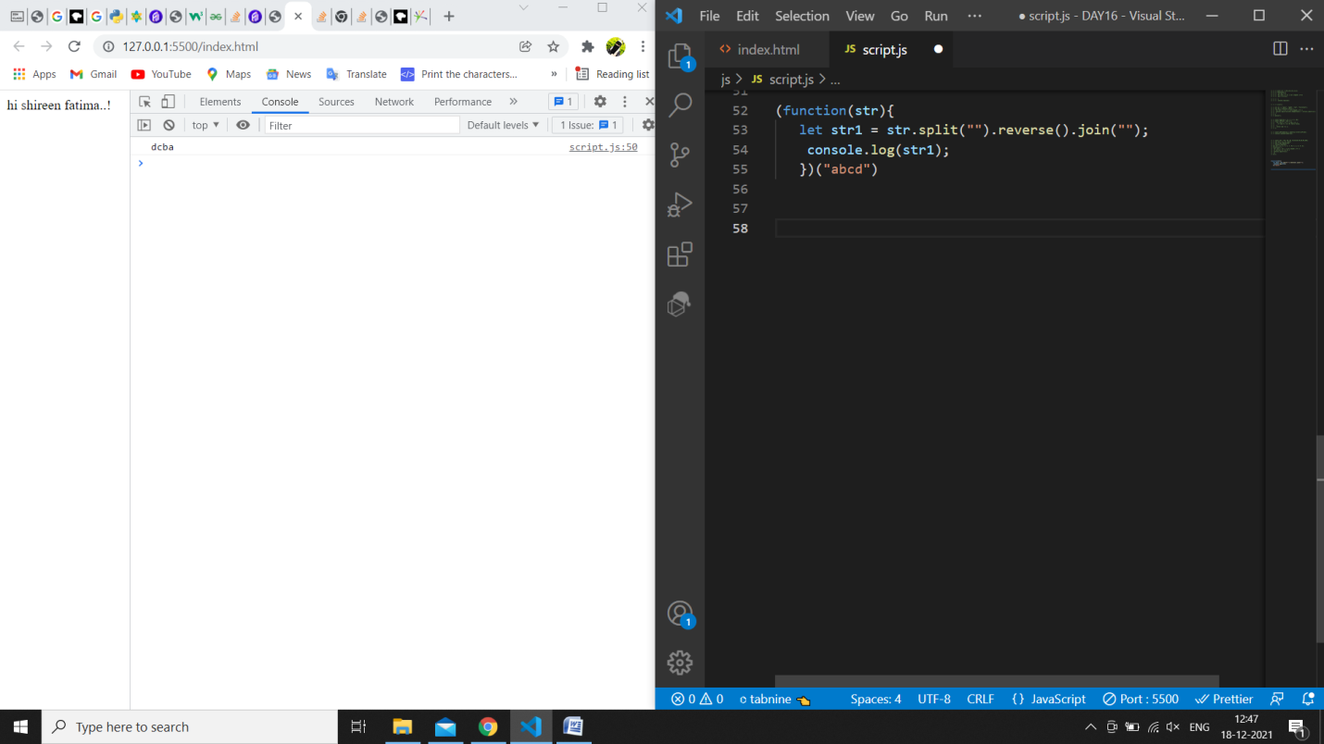

Sum of odd numbers in an array

var as=[12,34,5,6,2,56,6,2,1];

var s=as.reduce(function(a,c){

 if(c%2!=0)

 {

 return a+c;

 }

 else

 return a;

});

console.log(s);

0/p: 18

Rotate array by k position

var arr = [1, 2, 3, 6, 8, 6, 1, 9, 10, 12, 13];

var k = 3;

 (function() {

     var out = arr.slice(arr.length-k, arr.length);

       var count = out.length;

        for (var i = 0; i <=arr.length-k-1; i++) {

             out[count] = arr[i];

             count += 1;

             }

             console.log(out);})();

swapping array by its even and odd basis

let str = '1234';

let a = [...str];

let result = [];

for (let i = 0; i < a.length - 1; i++) {

for (let j = 0; j < a.length - 1; j++) {

if (a[j] % 2 != 0) {

let temp = a[j];

a[j] = a[j + 1];

a[j + 1] = temp;

}

}

}

for (let i = 0; i < a.length; i++) {

result.push(a[i] + ' ')

}

console.log(result.join(' '))

Expected Output: [ {firstName: “Vasanth”, lastName: “Raja”, age: 24, role: “JSWizard”}, {firstName: “Sri”, lastName: “Devi”, age: 28, role: “Coder”} ]

var array =[     [['firstname','vasanth'],

['lastname','Raje'],['age',24],['role','JSWizard']],

  [['firstname','Sri'],['lastname','Devi'],['age',28],['role', 'Coder']] ];

  var final=[]

   while(array.length!=0) {

    var outer_remove = array.shift();

    new_object={}; while(outer_remove.length>0)  {

    var inner_remove = outer_remove.shift()

    var key = inner_remove[0]

    var value =inner_remove[1]

     new_object[key]=value  }

    final.push(new_object) ;

    }

    console.log(final);